Consider a very small collection C that consists of the following three documents (used it as Wiki collection):

d1: “scary green crocodile.”
d2: “scary green big”
d3: “small crocodile”

For all the documents, use the tf-idf score for term weighting and use cosine similarity for relevance measurement. Assume that the words in the vectors are ordered alphabetically. Clearly indicate your answer for each step (e.g., draw term-document matrices for tf, idf, tf*idf respectively)
The idf (inverse document frequency) of a term t is defined by

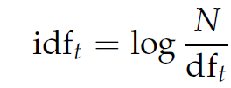

Where N is the total number of documents in a collection, and df_{t} is the document frequency of t.

Questions:
- Compute the semantic interpreter for text “green crocodile”
- Given two pieces of text: “big crocodile” and “scary crocodile”, calculate their similarity based on their ESA scores, i.e. compare their vectors using the cosine similarity (Don’t forget to compute the lengths of the vectors (if needed, use log2(3/1)=1.584 and log2(3/2)=0.584))

